Letter to all Members of Parliament standing down at the next General Election - please send it to your MP
Dear
We understand that you and 70 other MPs are standing down at the next election. We believe this puts you all, as a group, in a unique position to ask probing questions of the government and the opposition front benches, questions that may have been in your mind to ask but which were put to one side in an effort to pull together during the pandemic. As you come towards the end of what, for some of you, have been decades of public service, your overriding responsibility is to set aside party divisions and to focus on the people who elected you.
You will all have constituents who have suffered in numerous ways from the management of the pandemic, whether adults whose mental health or financial stability or access to health care was impacted, or children whose schooling was disrupted. Whether you know them or not, you will also all have constituents who have suffered serious adverse events from the Covid-19 vaccines, yet very few MPs have attended debates on this matter. Only last month, Yasmin Qureshi led a debate on the plight of women whose unborn babies were damaged by a hormone pregnancy test in use in the 1960s and who are still seeking recognition. The plight of the Covid-vaccine-injured is following the same slow pathway.
Most seriously, there has been significant excess mortality across all age groups in 2022 and 2023 in the UK; these are predominantly non-Covid deaths. There are serious grounds for thinking that at least a proportion of these deaths are related to the vaccine rollout, but the government and its advisors are reluctant to even consider this possibility. Excess Covid deaths during the first year or two of any pandemic are to be expected, thereafter excess deaths would usually disappear and the cumulative line flatten since weaker and more vulnerable people have already died prematurely during the pandemic year(s). But this did not happen and excess deaths have continued throughout 2022 and 2023, as clearly shown in Figure 1.
The size of this surge in deaths particularly in younger age groups is shown in the Figure 2, with excess deaths occurring for all age groups 0-65 for every month since June 2022.
The cause needs urgent and transparent investigation - are they delayed effects of covid infections, covid vaccines, lockdowns or indeed some altogether different explanation? Without a root cause analysis, we cannot begin to find ways to reverse this trend.
As you move into your final year as an MP, we implore you to look with an open mind at all these issues and consider whether you can add your support to the so far small band of MPs from across the political spectrum who are trying to improve public safety. An Adjournment Debate on the excess deaths has been secured for Friday 20th October and we urge you to attend.
Mr Nick Hunt Dr Clare Craig Venetia Taylor Dr Elizabeth Evans
www.perseus.org.uk www.hartgroup.org www.thinkingcoalition.org www.Ukmedfreedom.org
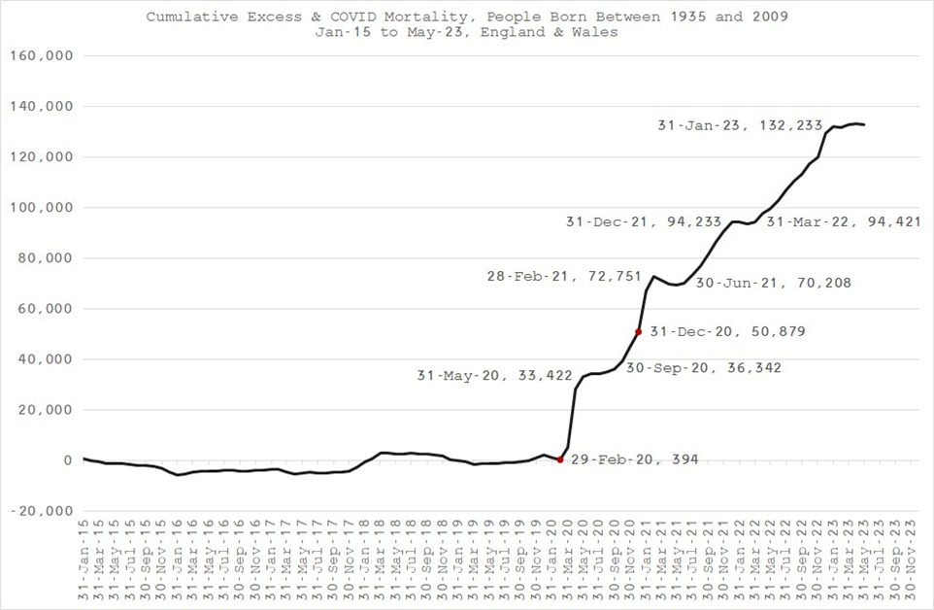
Figure 1. Cumulative Excess mortality all age groups, Jan 2015 to May 2023 (ONS data)
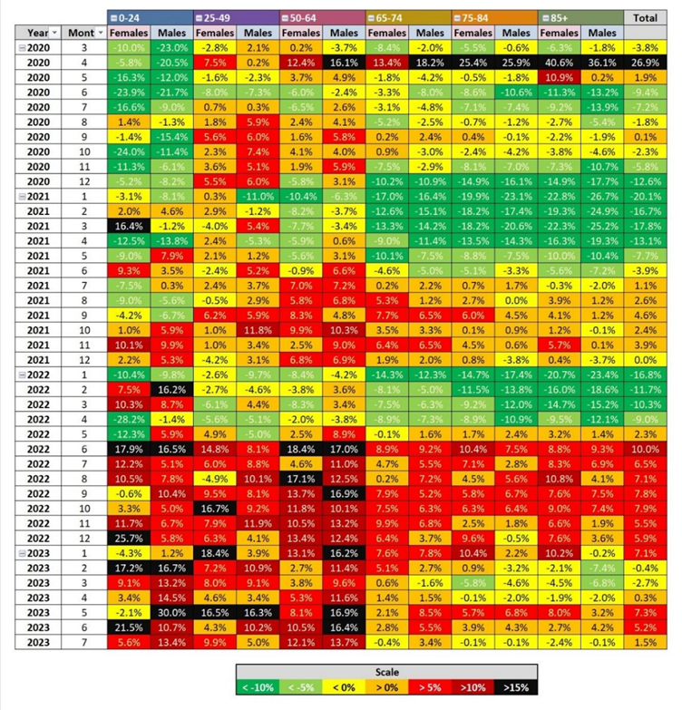
Figure 2. Heat map showing distribution of excess non-covid deaths by age group (data from Office for Health Improvement & Disparities)

Co-signed by the many health professional and academics listed below:
- Professor Angus Dalgleish, MD, FRCP, FRACP, FRCPath, FMedSci, Professor of Oncology, University of London; Principal, Institute for Cancer Vaccines & Immunotherapy
- Professor John A Fairclough, BM BS, BMed Sci, FRCS, FFSEM(UK), Professor Emeritus, Honorary Consultant Orthopaedic Surgeon
- Professor Norman Fenton, CEng, CMath, PhD, FBCS, MIET, Emeritus Professor, Queen Mary University of London
- Professor David Livermore, BSc, PhD, retired Professor of Medical Microbiology
- Professor Martin Neil, BSc PhD, Professor of Computer Science and Statistics
- Professor Roger Watson, FRCP Edin, FRCN, FAAN, Honorary Professor of Nursing, University of Hull
- Lord Moonie, MBChB, MRCPsych, MFCM, MSc, House of Lords, former parliamentary under-secretary of state 2001-2003, former consultant in Public Health Medicine
- Dr Ali Ajaz, Consultant Psychiatrist
- Wendy Armstrong, Practice Nurse
- Helen Auburn, Dip ION, MBANT, NTCC, CNHC, Registered Nutritional Therapist
- Dr Ian Barros D’Sa, BM, MRCS, FRCR, PGCMEd, Consultant Radiologist
- Dr Michael Bazlinton, MBChB, MRCGP, DCH, General Practitioner
- Dr David Bell, MBBS, PhD, FRCP(UK), Specialist in Public Health
- Dr Mark A Bell, MBChB, MRCP(UK), FRCEM, Consultant in Emergency Medicine, UK
- Dr David Bramble, MBChB, MRCPsych, MD, Consultant Psychiatrist
- Dr Gillian Breese, BSc, MB ChB, DFFP, DTM&H, General Practitioner
- Dr Emma Brierly, MBBS, MRCGP, General Practitioner
- Dr Rachel Brown, MBChB, LLM, CFMP, MRCPsych
- Mr John Bunni, MBChB (Hons), Dip Lap Surg, FRCS [ASGBI Medal], Consultant Colorectal and General Surgeon
- Dr Elizabeth Burton, MB ChB, Retired General Practitioner
- Dr David Cartland, MBChB, BMedSci, General practitioner
- Angela Chamberlain, BSc (hons), Midwife
- Dr Peter Chan, BM, MRCS, MRCGP, NLP, General Practitioner, Functional Medicine Practitioner
- Dr Selena Chester, MBBS, Medical Practitioner
- Dr Marco Chiesa, MD, FRCPsych, Consultant Psychiatrist, Visiting Professor
- Michael Cockayne, MSc, PGDip, SCPHNOH, BA, RN, Occupational Health Practitioner
- James Cook, BN, MPH, NHS Registered Nurse
- Dr David Critchley, BSc, PhD, 32 years in pharmaceutical R&D as a clinical research scientist
- Dr Matthew Dennison, MBBS, MRCGP, Dip IBLM, General Practitioner
- Dr Christine Dewbury, MBBS, retired General Practitioner
- Dr Keith Dewbury, MBBS, FRCR, retired Consultant Radiologist
- Dr James Dyson, MRCS LRCP, MA, retired Medical Practitioner
- Dr Jonathan Eastwood, BSc, MBChB, MRCGP, General Practitioner
- Dr Jonathan Engler, MBChB, LlB (hons), DipPharmMed
- Dr Chris Exley, PhD FRSB, retired professor in Bioinorganic Chemistry
- Dr John Flack, BPharm, PhD. Retired Director of Safety Evaluation at Beecham Pharmaceuticals 1980-1989 and Senior Vice-president for Drug Discovery 1990-92 SmithKline Beecham
- Dr Nick Flatt, BMSc(Hons), MBChB, FRCSEd, FRCA, FFPMRCA, retired Consultant Anaesthetist
- Dr Charles Forsyth, MBBS, FFHom, Ecological and Homeopathic Physician (Retired)
- Dr Sheena Fraser, MBChB, MRCGP (2003), Dip BSLM, General Practitioner
- Sophie Gidet, RM, Midwife
- Dr Henry Goodall, MBBS, FFOM, retired Consultant Occupational Health Physician, President of the Society of Occupational Medicine, 2011-12
- Dr Jenny Goodman, MA, MBChB, Ecological Medicine
- Cheryl Grainger, BSc, Pharma Training Consultant
- Dr Cathy Greig, MBChB (hons), General Practitioner
- Dr Ali Haggett, Mental health community work, 3rd sector, former lecturer in the history of medicine
- Mr David Halpin, MBBS, FRCS, Orthopaedic and trauma surgeon, retired
- Dr Catherine Hatton, MBChB, General Practitioner
- Alex Hicks, MEng, MCIPS, Compliance Director (Supply Chain)
- Mr Anthony Hinton, MBChB, FRCS, Consultant ENT surgeon, London
- Dr Richard House, PhD, CPsychol, AFBPsS, CertCouns, Chartered Psychologist, former senior lecturer in Psychology (Roehampton) and Early Childhood (Winchester), retired psychotherapist
- Dr Keith Johnson, DPhil, former patents officer
- Fiona Jones, BScHons, DipPreSci, PgCertMed Ed, MFRPSII, FRPharmS, retired Clinical lead pharmacist
- Dr Ros Jones, MBBS, MD, FRCPCH, retired Consultant Paediatrician
- Eshani King BSc (Hons) FCA CTA BFP - Evidence Based Research in Immunology and Health
- Dr Tanya Klymenko, PhD, FHEA, FIBMS, Senior Lecturer in Biomedical Sciences
- Dr Caroline Lapworth, MB ChB, General Practitioner
- Dr Branko Latinkic, BSc, PhD, Molecular Biologist
- Dr Theresa Lawrie, MBBCh, PhD, Director, Evidence-Based Medicine Consultancy Ltd
- Dr Andrew Lees, MB BS, MRCGP, DCH, retired General Practitioner
- Dr Felicity Lillingstone, IMD DHS PhD ANP, Doctor, Urgent Care, Research Fellow
- Dr Nichola Ling, MBBS, MRCOG, Consultant obstetrician and digital advisor to NHS England
- Mr Malcolm Loudon, MB ChB, MD, FRCSEd, FRCS (Gen Surg). MIHM, VR, Consultant Surgeon
- Katherine MacGilchrist, BSc (Hons) Pharmacology, MSc Epidemiology, CEO, Systematic Review Director, Epidemica Ltd
- Dr Kulvinder S. Manik MBChB, MRCGP, MA(Cantab), LLM, Gray’s Inn
- Dr C Geoffrey Maidment, MD, FRCP, retired consultant physician
- Kaira McCallum, BSc, retired pharmacist, Director of strategy UKMFA
- Mr Ian McDermott, MBBS, MS, FRCS(Tr&Orth), FFSEM(UK), Consultant Orthopaedic Surgeon
- Dr Janet Menage, MA, MBChB, retired General Practitioner
- Dr Alistair J Montgomery, MBChB, MRCGP, DRCOG, retired General Practitioner
- Dr Alan Mordue, MBChB, FFPH, retired Consultant in Public Health Medicine & Epidemiology
- Dr David Morris, MBChB, MRCP(UK), General Practitioner
- Margaret Moss, MA(Cantab), CBiol, MRSB, Director, The Nutrition and Allergy Clinic, Cheshire
- Dr Claire Mottram, BSc Hons, MBChB, Doctor in General Practice
- Dr Greta Mushet, MBChB, MRCPsych, retired Consultant Psychiatrist in Psychotherapy
- Dr Angela Musso, MD, MRCGP, DRCOG, FRACGP, MFPC, General Practitioner
- Julie Nicholls, LCSP(Phys), IEMT, former RGN, Body~Mind Coach
- Dr Rachel Nicoll, PhD, Medical researcher
- Tim Nike, Specialist Neurological Physiotherapist
- Dr Christina Peers, MBBS, DRCOG, DFSRH, FFSRH, Menopause Specialist
- Rev Dr William J U Philip MB ChB, MRCP, BD, Senior Minister The Tron Church Glasgow, formerly physician specialising in cardiology
- Dr Angharad Powell, MBChB, BSc (hons), DFRSH, DCP (Ireland), DRCOG, DipOccMed, MRCGP, General Practitioner
- Dr Gerry Quinn, PhD, Microbiologist
- Jessica Righart, MSc, MIBMS, Senior Biomedical Scientist
- Mr Angus Robertson, Orthopaedic Surgeon
- Dr Jon Rogers, MB ChB (Bristol), retired General Practitioner
- Mr James Royle, MBChB, FRCS, MMedEd, Colorectal Surgeon
- Dr Alison Sabine, MBChB, MRCP, Consultant Rheumatologist
- Dr Salmaan Saleem, MBBS, BMedSci, General Practitioner
- Sorrel Scott, Grad Dip Phys, Specialist Physiotherapist in Neurology, 30 years in NHS
- Natalie Stephenson, BSc (Hons) Paediatric Audiologist
- Dr Noel Thomas, MA, MBChB, DObsRCOG, DTM&H, MFHom, Retired Doctor
- Dr Livia Tossici-Bolt, PhD, NHS Clinical Scientist
- Dr Jannah van der Pol, iBSc, MBBS, MRCGP, General Practitioner
- Dr Helen Westwood, MBChB (Hons), MRCGP, DCH, DRCOG, General Practitioner
- Dr Carmen Wheatley, DPhil, Orthomolecular Oncology
- Dr Samuel White, MBChB, MRCGP, Functional Medicine Specialist, former General Practitioner
- Mr Lasantha Wijesinghe, FRCS, Consultant vascular surgeon
- Dr Lucie Wilk, MD, MRCP, Rheumatologist
- Dr Stephanie Williams, Dermatologist
- Dr AZ, MBChB, NHS Specialty doctor

